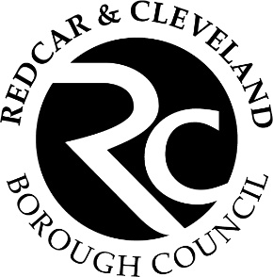
Volunteer Role Description

Guisborough Forest & Walkway Reception Volunteer

Within this role you will be a friendly first point of contact welcoming visitors to the country park. Working under the guidance of the Visitor Centre Assistant the primary role is to provide visitors with information and services they need to make the most out of their visit.

This opportunity will suit someone who:
- Has excellent communication skills
- Has an interest in nature
- Positive attitude
- Enjoys greeting visitors to deliver a high-quality visitor experience
- Answer questions and provide visitor information about the park facilities, maps, trails, planned events and the local wildlife
- Handling enquiries by telephone and in person to assist with event and activity registration and bookings.
- Work as part of a team to help maintain and tidy the reception area

We require all volunteers to attend training as part of their role. Volunteers will be given guidance and support, so they feel confident working independently. As this role involves lone working, volunteers must be over 18 years.
For more information, please contact volunteer@redcar-cleveland.gov.uk

