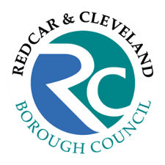
Financial Publications
Statement of Accounts 2025/26 – Public Inspection Notice

Notice of the Commencement of the Period for the Exercise of Public Rights in relation to the Statement of Accounts of Redcar & Cleveland Borough Council for the financial year ended 31 March 2026:

- The Local Audit and Accountability Act 2014
- The Accounts and Audit Regulations 2015

Rights to inspect the statement of accounts and accounting records under Sections 25 & 26 of the Local Audit and Accountability Act 2014 (‘the Act’) provide local government electors with the right to inspect and make copies of the statement of accounts, accounting records and all documents relating to those records, for the financial year ended 31 March 2025.

These rights may be exercised from 01/07/2026 to 12/08/2026, between the hours of 09.30 and 16.30 at the address below:

Redcar and Cleveland House
Kirkleatham Street
Redcar
TS10 1AR

Please contact Phil Winstanley either by telephone on 01642 774774 or via email at philip.winstanley@redcar-cleveland.gov.uk to arrange a suitable date and time.

Under sections 26 & 27 of the Act, a local government elector may also question the auditor about the accounting records for the financial year ended 31 March 2026 and, under section 27 of the Act, a local government elector may make an objection to the auditor which:

- concerns a matter in respect of which the auditor could make a public interest report under section 24 of the Act; or
- concerns an item of account in respect of which the auditor could apply for a declaration that the item is unlawful under section 28 of the Act.

These rights may also be exercised from 01/07/2026 to 12/08/2026. Any requests to question the auditor and any objections must be made in writing to James Collins (Director) at the following address:

The Corner
Bank Chambers
26 Mosley Street
Newcastle upon Tyne
NE1 1DF

A copy of any objection must also be sent to the Council at the address set out above.
PHIL WINSTANLEY – Director of Finance (Section 151 Officer)

