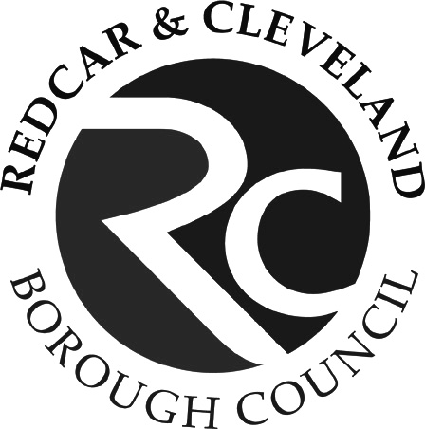
Application form for assistance with home to school travel – September 2025 to July 2026
Form:
H2S1

Please read through the eligibility criteria below and complete this form to apply for assistance with home to school travel as appropriate.

Please note the Transport Team require a minimum of 20 working days to assess applications and make transport arrangements.
A: Distance to school

Up to 8 years of age | Travel assistance is available to children attending their nearest appropriate school more than two miles walking distance from home along the shortest safe walking route.
Between 8 years and 16 years | Travel assistance is available for children attending their nearest appropriate school more than three miles walking distance from home along the shortest safe walking route.
B: Low income:

Children will meet low income criteria if entitled to:
- free school meals on grounds of low income, or
- If parents are in receipt of the maximum level of Working Tax Credit (the level of entitlement to Working Tax Credit is shown on the notice issued by H.M. Revenue and Customs) and if:

- The nearest suitable school is beyond 2 miles (for children over the age of 8 and under 11 years);

- The school is between 2 and 6 miles (if aged 11-16 years and there are not three or more suitable nearer schools);

- The school is between 2 and 15 miles and is the nearest school preferred on grounds of religion (aged 11-16 years). Please Note: A certificate of baptism is required to confirm eligibility on grounds of religion and free travel will not be provided if places are available in another suitable faith school closer to home

Please Note: Evidence of low income will be required and should accompany your application form. The Council administer Free School Meals for some schools, where this is the case we will check our records to determine if you are eligible. For all other schools you will need to provide proof of Free School Meals such as a screen shot of your eligibility email. Information about how to apply and which schools the Council administer Free School Meals for is available at https://www.redcar-cleveland.gov.uk/schools-and-education/free-school-meals

C: Unsafe walking
Travel assistance will be available where children live within statutory walking distance but the nature of the route is such that a child cannot reasonably be expected to walk (accompanied as necessary) in reasonable safety.

In determining whether a route is safe, the Council will consider whether the child could reasonably be expected to walk if accompanied and if so, whether the child’s parent can reasonably be expected to accompany the child.

When determining eligibility, a range of factors will be taken into consideration as stated in the Councils Home to School Policy.

In reaching decisions on suitable safe routes, the Council will not override a parent’s legal responsibility to ensure their child attends school regularly and punctually. The fact that parents may face other pressures at this time, such as the need to go to work, is not in itself sufficient reason for the Council to provide travel support. In all cases it will be at the Council’s discretion to determine whether or not it is reasonable for parents to accompany their children on the school journey.

Other support
If your child has special education or medical needs, please contact Children & Families Services for advice.

Please send completed forms to:
Redcar and Cleveland Borough Council, Transport Team
Fairway House, Redcar, TS10 5JU
Email Transport@redcar-cleveland.gov.uk

Further information from:
Children & Families: Phone: 01642 776 906
Free school meals enquiries: Phone: 01642 771 106
www.redcar-cleveland.gov.uk

Where applications are for siblings attending the same school please include all students on this form. If you have children attending different schools separate forms are required.

Student 3
Student’s Full Name
Date of Birth
School Year (as at Sept 2025)
School they will be attending
Home Address
Post Code
Is the student in receipt of free school meals due to low income? |  | Yes | Tick | No | Tick
Does the student have an Education Health and Care Plan |  | Yes | Tick | No | Tick

Student 3
Student’s Full Name
Date of Birth
School Year (as at Sept 2025)
School they will be attending
Home Address
Post Code
Is the student in receipt of free school meals due to low income? |  | Yes | Tick | No | Tick
Does the student have an Education Health and Care Plan |  | Yes | Tick | No | Tick

Student 3
Student’s Full Name
Date of Birth
School Year (as at Sept 2025)
School they will be attending
Home Address
Post Code
Is the student in receipt of free school meals due to low income? |  | Yes | Tick | No | Tick
Does the student have an Education Health and Care Plan |  | Yes | Tick | No | Tick

Name of Person Making this Application:
Relationship to Child:
Contact Number:
Email Address:
Passport Photographs
If your child is attending Freebrough, Laurence Jackson or Outwood Academy Redcar please attach a passport style photograph this will be required if a bus pass is awarded.
Please write the child’s name, and date of birth on the back, if you are submitting the application by email please provide a passport photo as an attachment the file name should be the child’s name and DOB.

Criteria: Please tick one or more of the following categories to indicate the eligibility criteria under which you are applying for transport assistance. Guidance on each category is shown overleaf:

Reason for your application for free travel:
A: Distance to school | Tick
B1: Low Income Free School Meals | Tick
B2: Low Income – Maximum Tax Credits | Tick
C: Unsafe Walking | Tick
D. Nearest School Full | Tick

Further Information in Support of your Application|:

GDPR statement
Redcar and Cleveand Borough Council processes personal data in accordance with the Data Protection Act 2018 and UK GDPR. For further information on how your data is used please visit Education Privacy Notice | Redcar and Cleveland

Declaration
- I confirm that the information provided on this form is true and accurate. I will inform the Transport Team immediately of any change of circumstance which might affect any entitlement to support. I understand that if it is found that transport has been awarded by the Council based on incorrect or inaccurate information, or if I fail to provide information about a change of circumstance, that the Council reserves the right to reclaim the full cost of any transport assistance provided
- I understand that if I knowingly provide false information, travel assistance will be withdrawn.
- I undertake to ensure that where a permit has been issued that any permit no longer required will be returned immediately to the Council.
- I understand that a change of address may mean that I am no longer eligible for assistance with transport and I undertake to inform the Council of any such changes.
- By submitting this application I undertake to pay any charges which may be due under the eligibility criteria detailed and applied for above.
I have read and agree with the above declaration. ☐

Signed by Parent/Carer: ____________________________ Date: ________________

