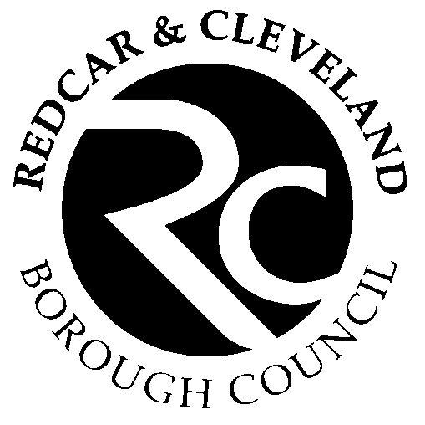

Form 8a - Self-Assessment: Food Safety Checklist for food vehicle/ stall holders at events

Requirement | ✓ ✗ N/A | Details – How do you meet the requirement?
Registering as a food business  You must register with your local Environmental Health Team  This is usually where you run your business from.  If you are not already registered go to:  How to register a food business / Food Standards Agency |  | Local Authority Name:  Date Registered:
Previous inspection  You should be able to demonstrate that you have had a food hygiene inspection and (if relevant) have been given a food hygiene rating. |  | Date of Last Inspection:  Food Hygiene Rating:
You will need to have a written food safety document that explains what you do to ensure your food is safe. The document should be kept with your vehicle / stall  The Safer food, better business (SFBB) / Food Standards Agency is an example of a suitable document.  All of the written safe procedures must be completed, and records kept up to date. |  | SFBB/ In-house/ other:
You must be able to give customers accurate information about allergens are in your foods. Allergen guidance for food businesses / Food Standards Agency and let customers know how to get this information. This may be by displaying an Allergen sign |  | Allergens Identified – how is this recorded?  Sign displayed:
Food must be accurately described and be what it says it is so that customers are not misled. Pre-packed foods require labelling. Packaging and labelling / Food Standards Agency
You and your staff must have training on food safety including allergens. Free online allergen training can be accessed at Food Standards Agency food allergy online training |  | Training completed:
You vehicle / stall and equipment must be clean and well maintained. There should be no risk of contamination to foods. |  | What do you do to ensure this:
You will need enough sinks for cleaning equipment and washing food; they must be supplied with hot and cold water. |  | Location of sinks:  Hot and cold water provided by:
You will need suitable cleaning materials including clean or disposable cloths, detergent and, where necessary, disinfectant (which meets the BS: EN 1276 or 13697) |  | Cloths used:  Detergent used:  Disinfectant used:
You will need a suitable and accessible hand wash basin (separate to sinks). This must be provided with hot and cold (or warm) water and a supply of soap and paper towels. |  | Location of hand wash basin:  Hot and cold water provided by:  Soap and towels:
You will need enough clean water for the time of the event and somewhere to drain the water to. If there is no mains water or drainage you need suitable containers for this.
You will need bins / refuse sacks for rubbish and somewhere to store them and dispose of them
You must have adequate equipment which can heat foods and keep foods at a safe temperature.  -cook above 75oC , keep hot above 63oC, keep cold below 8oC. |  | Temperature controlled equipment:  Details of temperature checks to show the equipment is working:
Raw and ready to eat foods must be kept apart to prevent cross contamination.

Do you and staff have washable, clean overalls?

